Preview of table member addresses before normalization:

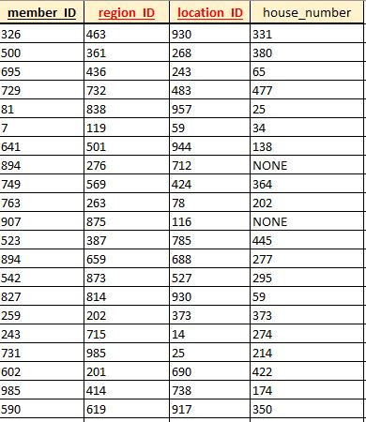

Table don’t need to be normalized, it’s in 3NF already.

FK’s are region_ID, location_ID.

PK is member_ID.